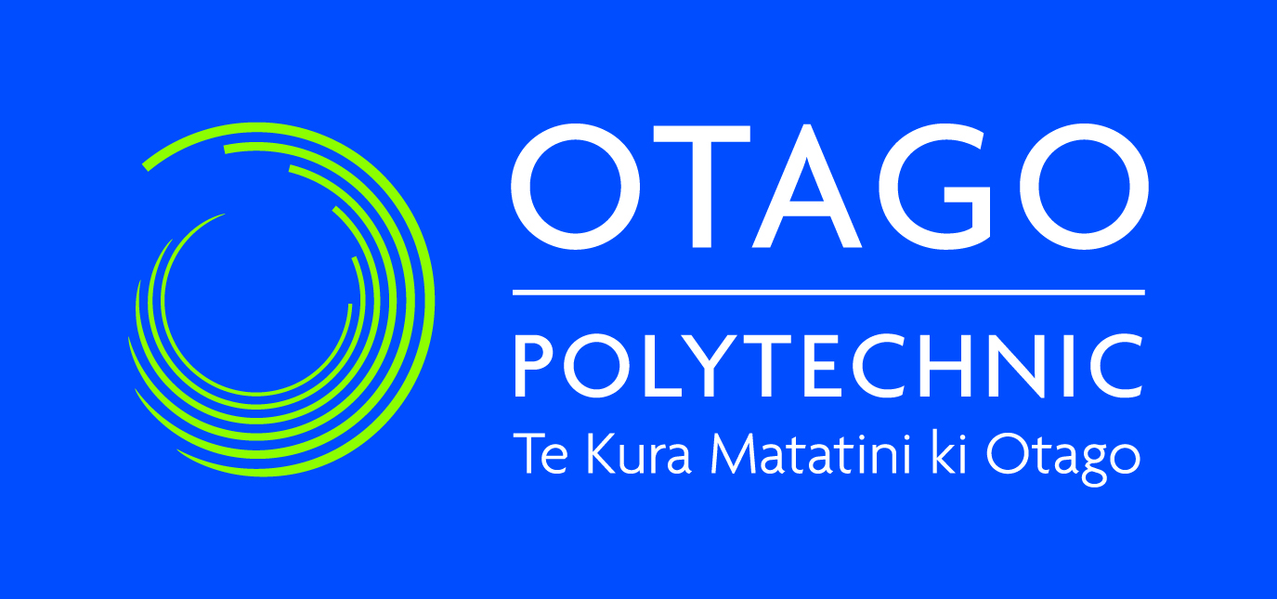

**COURSE DIRECTIVE**

***Bachelor of Information Technology***

*IN721: Mobile Application Development*

*Semester One, 2020*

**DESCRIPTION**

This paper aims to provide a broad introduction to mobile-based development. Students will be able to design, create, test and publish mobile applications using industrially relevant technologies.

**COURSE INFORMATION**

Credits: 15 credits

Perquisites: IN610 Programming 3

**LECTURER**

Name: Grayson Orr (Lecturer)

Location: D311

Email: grayson.orr@op.ac.nz

**COURSE DATES**

Term 1:

Mid semester break:

Term 2 :

**AIMS**

To learn the specifics of mobile applications design and development. Students will be able to develop a mobile application and publish it to a mainstream app store.

**LEARNING OUTCOMES**

At the successful completion of this course, students will be able to:

1. Implement and deploy a complete, non-trivial, industry-standard mobile applications following sound architectural and code-quality standards
2. Identify relevant use cases for a mobile computing scenario and incorporate them into an effective user experience design.
3. Follow industry standard software engineering practice in the design of mobile applications.

**RESOURCES**

**Software**

This paper will be taught using **Microsoft Visual Studio Code** and **Expo**. An installer for **Microsoft Visual Studio Code** is available. See https://secure.ict.op.ac.nz/msdnaa/. Please refer any problems with downloads or installers to **Rob Broadley** in **D205a**.

**Readings**

There is no textbook for the course.

**PROVISIONAL SCHEDULE**

|  |  |  |  |
| --- | --- | --- | --- |
| **Week** | **Date** | **Session 1** | **Session 2** |
| **1** |  | Introduction to React Native and Expo | React Basics |
| **2** |  |  |  |
| **3** |  |  |  |
| **4** |  |  |  |
| **5** |  |  |  |
| **6** |  |  |  |
| **7** |  |  |  |
| **8** |  |  |  |
| **9** |  |  |  |
| **10** |  |  |  |
| **11** |  |  |  |
| **12** |  |  |  |
| **13** |  |  |  |
| **14** |  |  |  |
| **15** |  | Assessment Work | Assessment Work |
| **16** |  | Exam Preparation | Exam |

**ASSESSMENT**

|  |  |  |
| --- | --- | --- |
| **Assessment** | **Weight** | **Due Date** |
| In-class checkpoints | 25% | Weekly |
| Assignment 1 | 25% |  |
| Assignment 2 | 25% |  |
| Assignment 3 | 25% |  |

Detailed assignment requirements, including instructions for submission, will be provided for each assessment.

**COURSE REQUIREMENTS & EXPECTATIONS**

**Learning Hours**

This course requires 150 hours of learning. This time includes 64 hours of timetabled class time, and 86 hours of self-directed reading, preparation and completion of assessment work.

**Criteria for Passing**

To pass this paper, you must achieve an overall average of 50. There must be a genuine attempt at all assessments. There are no resits.

**Attendance**

* Students are expected to attend all classes, both lectures and labs.
* If you miss a class, you will need to get notes from another student.
* If you cannot attend for a few days for any reason, please contact your lecturer.
* You must turn up ready for assessments on the due date and at the correct time. No extra time will be scheduled. If you do not turn up, you have failed the assessment.

**Communication**

Microsoft Outlook and Teams are the official communication channels. It is your responsibility to regularly check Microsoft Outlook/Teams and GitHub for important course related material, including changes to class scheduling or assessment details. Not checking will not be accepted as an excuse.

**Snow Days/Polytechnic Closure**

In the event the Polytechnic is closed or has a delayed opening because of snow or bad weather, you should not attempt to attend class if it is unsafe to do so. It is possible that your instructor will not be able to attend either, so classes will not physically be meeting. However, this does not become a holiday. Rather, material will be made available on GitHub for classes affected by the closure. You are responsible for any material presented in this manner. Information about closure will be posted on the Otago Polytechnic Facebook page https://www.facebook.com/Otago.

**Group Work and Originality**

Students in the Bachelor of Information Technology degree are expected to hand in original work. Students are encouraged to discuss assessments with their fellow students, however, all assessments are to be completed as individual works unless group work is explicitly required (i.e. if it doesn’t say it is group work then it is not group work – even if a group consultation was involved). Failure to submit your own original work will be treated as plagiarism.

**Referencing**

Appropriate referencing is required for all work. Referencing standards will be specified by your lecturer.

**Plagiarism**

Plagiarism is submitting someone else’s work as your own. Plagiarism offences are taken seriously and an assessment that has been plagiarised may be awarded a zero mark. A definition of plagiarism is in the Student Handbook, available online or at the School office.

**Submission Requirements**

All assessments are to be submitted by the time, date, and method given when the assessment is issued. Failure to meet all requirements may result in a penalty of up to 10% per day (including weekends).

**Extensions**

Extensions are only available for unusual circumstances. These must be applied for, and approved, prior to the submission deadline.

**Impairment**

In case of sickness contact your lecturer or BIT Team Leader (Joy Gasson) as soon as possible, preferably before the assessment or exam is due. The policy regarding the granting of a mark that considers impaired performance requires a medical certificate and a medical practitioner’s signature on a form. You may should refer to the guide on impaired performance on the student handbook.

**Appeals**

If you are concerned about any aspect of your assessment, please approach the lecturer in the first instance. We support an open-door policy and aim to resolve issues promptly. Further support is available from the BIT Team Leader (Joy Gasson) and Head of College (Richard Nyhof). Otago Polytechnic has a formal process for academic appeals if necessary.

**Other Documents**

Regulatory documents relating this course can be found on the Polytechnic website.